Subject Name: Project Subject Code: KCS-753

Smart Facial Attendance System

A PROJECT REPORT

Submitted by

Gaurav Kumar Verma – 2004920100021
Pratyush Harsh – 2004920100035
Aditya Pandey – 2004921530001
Raj Aryan - 2004920100038

Under the Guidance

Of

Mr. Rohit Negi

in partial fulfilment for the award of the degree

of

Bachelor of Technology

IN

Computer Science Engineering, 4th YEAR & 7th SEMESTER



KCC Institute of Technology & Management Affiliated by A.P.J. Abdul Kalam Technical University (AKTU) Knowledge Park, Greater Noida, U.P
February 2024
Subject Name: Project Subject Code: KCS-753

ACKNOWLEDGEMENT

It is our privilege and pleasure to express a profound sense of respect, gratitude and indebtedness to our Mr. Balak Ram, Assistant Professor, Dept. of Computer Science and Engineering, KCC Group of Institutions for his/her indefatigable inspiration, guidance, cogent discussion, constructive criticisms and encouragement throughout this dissertation work.

We express our sincere gratitude to Dr. Harvendra Kumar Patel, Associate Professor & Head, Department of Computer Science and Engineering, KCC Group of Institutions, for his suggestions, motivations and co-operation for the successful completion of the work.

We extend our sincere thanks to Mr. Deepak Gupta, Chairman, KCC Group of Institutions for his encouragement.

Gaurav Kumar Verma – 2004920100021

Pratyush Harsh - 2004920100035

Aditya Pandey - 2004921530001

Raj Aryan - 2004920100038
Subject Name: Project Subject Code: KCS-753

DECLARATION

This is to declare that the project report entitled Smart Facial Attendance System submitted by me to KCCITM College, Greater Noida, U.P. in partial fulfilment for the award of the degree of Bachelor of Technology is a record of work carried out by me at KCCITM College. The work, in full or in parts, has not been submitted to any other University/Institute for the award of any other degree. Any information/material used in the project from external sources has been appropriately acknowledged.

Date :
Place :

Gaurav Kumar Verma

2004920100021

Pratyush Harsh

2004920100035

Aditya Pandey

2004921530001

Raj Aryan
2004920100038

Subject Name: Project Subject Code: KCS-753

CERTIFICATE

This is to certify that the project entitled Smart Facial Attendance System submitted by Gaurav Kumar Verma (2004920100021), Pratyush Harsh (2004920100035), Aditya Pandey (2004921530001), Raj Aryan (2004920100038) to the KCCITM College, Greater Noida, U.P. for the award of the degree of Bachelor of Technology is a bonafide record of research work carried out by his/her under my supervision. The contents of this report, in full or in parts, have not been submitted to any other Institute or University for the award of any degree or diploma.

Date :

Place :

Mr. Rohit Negi

[Designation and Department of Guide]

ACKNOWLEDGEMENT

It is our privilege and pleasure to express a profound sense of respect, gratitude and indebtedness to our Mr. Balak Ram, Assistant Professor, Dept. of Computer Science and Engineering, KCC Group of Institutions for his/her indefatigable inspiration, guidance, cogent discussion, constructive criticisms and encouragement throughout this dissertation work.

We express our sincere gratitude to Dr Sanjay, Associate Professor & Head, Department of Computer Science and Engineering, KCC Group of Institutions, for his suggestions, motivations and co-operation for the successful completion of the work.

We extend our sincere thanks to Mr. Deepak Gupta, Chairman, KCC Group of Institutions for his encouragement.

Gaurav Kumar Verma – 2004920100021

Pratyush Harsh -2004920100035

Aditya Pandey - 2004921530001

Raj Aryan - 2004920100038


Smart Facial Attendance System

ABSTRACT

In colleges, universities, organizations, schools, and offices, taking attendance is one of the most important tasks that must be done on a daily basis. The majority of the time, it is done manually, such as by calling by name or by roll number. The main goal of this project is to create a Face Recognition-based attendance system that will turn this manual process into an automated one. This project meets the requirements for bringing modernization to the way attendance is handled, as well as the criteria for time management. This device is installed in the classroom, where and student's information, such as name, roll number, class, sec, and photographs, is trained. The images are extracted using Open CV. Before the start of the corresponding class, the student can approach the machine, which will begin
taking pictures and comparing them to the qualified dataset. Logitech C270 web camera and NVIDIA Jetson Nano Developer kit were used in this project as the camera and processing board. The image is processed as follows: first, faces are identified using a Haarcascade classifier, then faces are recognized using the LBPH (Local Binary Pattern Histogram) Algorithm, histogram data is checked against an established dataset, and the device automatically labels attendance. An Excel sheet is developed, and it is updated every hour with the information from the respective
class instructor.

Keywords: Face Detection, Face Recognition, HarrCasscade classifier, Python, Py-Charm, NVIDIA Jetson Nano

INDEX
____________________________________________

- CHAPTER – 1 :

- Project Objective 1
- History of Face Recognition 2
- Background 4
- Problem Statement 5
- Flow Chart 6
- Basic Structure 7
- How it Works 8
- Sequence Diagram 10
- System Requirement 11
- Merits and Demerits 13

__________________________________________________________________________

- CHAPTER – 2 :

- Student Attendance System 14
- Digital Image Processing 14
- Image Representation in a Digital Computer 15
- Steps in Digital Image Processing 15
- Face Detection 16
- Face Recognition 18
- Difference between Face Detection and Face Recognition 19
- Local Binary Pattern Histogram 22
- LBPH Algorithm Work Step by Step 22
- Source Code 26

__________________________________________________________________________

- CHAPTER – 3 :

- It’s Objective 30
- It’s Scope 33

CHAPTER – 1
INTRODUCTION

- Project Objective :

Attendance is prime important for both the teacher and student of an
educational organization. So it is very important to keep record of the attendance.
The problem arises when we think about the traditional process of taking
attendance in class room.

Calling name or roll number of the student for attendance is not only a
problem of time consumption but also it needs energy. So an automatic
attendance system can solve all above problems.

There are some automatic attendances making system which are
currently used by much institution. One of such system is biometric technique
and RFID system. Although it is automatic and a step ahead of traditional method
it fails to meet the time constraint. The student has to wait in queue for giving
attendance, which is time taking.

This project introduces an involuntary attendance marking system,
devoid of any kind of interference with the normal teaching procedure. The
system can be also implemented during exam sessions or in other teaching
activities where attendance is highly essential. This system eliminates classical
student identification such as calling name of the student, or checking
respective identification cards of the student, which can not only interfere with
the ongoing teaching process, but also can be stressful for students during
examination sessions. In addition, the students have to register in the database
to be recognized. The enrolment can be done on the spot through the user-
friendly interface.

1.
- History of Face Recognition :

The history of face recognition dates back several decades, with advancements driven by developments in technology, artificial intelligence, and computer vision. Here's a brief overview of the key milestones in the history of face recognition:

1. Early Research (1960s-1970s) :
Early research in computer vision and pattern recognition laid the groundwork for face recognition algorithms.
- Woody Bledsoe, Helen Chan Wolf, and Charles Bisson conducted pioneering work on face recognition using simple geometric features.
- Takeo Kanade developed the first system for automated face recognition in 1973, which used 21 specific fiducial points on the face.

2. Eigenfaces (1987) :
In 1987, Sirovich and Kirby introduced the concept of Eigenfaces, a method for representing faces in a high-dimensional space.
- This approach enabled efficient face recognition by analyzing the principal components of face images.

3. Local Feature Analysis (1990s) :
In the 1990s, researchers began exploring methods based on local features, such as the eyes, nose, and mouth.
- Kanade, Cohn, and Tian introduced the Active Appearance Model (AAM) for face alignment and recognition, which utilized both global and local facial features.

4. Viola-Jones Algorithm (2001) :
Paul Viola and Michael Jones developed a real-time face detection algorithm based on Haar-like features and the AdaBoost machine learning algorithm.
- While primarily used for face detection, the Viola-Jones algorithm laid the foundation for subsequent face recognition systems.

5. Deep Learning Era (2010s) :
The emergence of deep learning revolutionized face recognition by enabling the development of highly accurate and scalable models.
- Deep convolutional neural networks (CNNs) such as AlexNet, VGG, and ResNet achieved breakthrough performance in image classification tasks, including face recognition.
- Notable face recognition systems leveraging deep learning include DeepFace by Facebook, FaceNet by Google, and DeepID by researchers at the Chinese University of Hong Kong.

2.

6. Commercial Applications and Adoption :
Face recognition technology gained widespread adoption in various applications, including surveillance, security systems, biometric authentication, and social media platforms.
- Companies like Apple, Microsoft, Google, and Amazon integrated face recognition into consumer products and services, such as smartphones, photo organization software, and smart home devices.

7. Ethical and Privacy Concerns :
The increasing deployment of face recognition systems raised concerns about privacy, surveillance, bias, and potential misuse of biometric data.
- Regulatory frameworks and guidelines, such as the European Union's General Data Protection Regulation (GDPR) and the California Consumer Privacy Act (CCPA), sought to address these concerns by imposing restrictions on the collection and use of biometric information.

The history of face recognition reflects a trajectory of continuous innovation driven by advances in technology and the growing demand for biometric authentication and identification solutions.

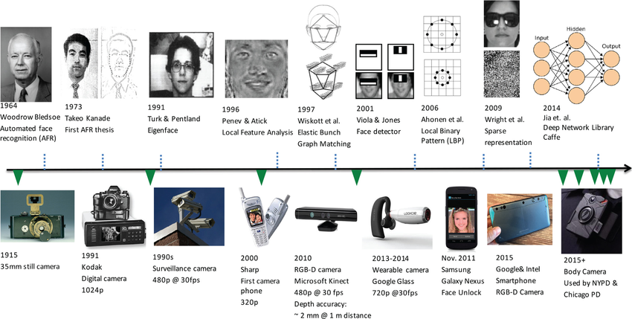

Fig.: History of Face Recognition

3.
- Background :

Face recognition is crucial in daily life in order to identify family, friends
or someone we are familiar with. We might not perceive that several steps have
actually taken in order to identify human faces. Human intelligence allows us
to receive information and interpret the information in the recognition process.

We receive information through the image projected into our eyes, by
specifically retina in the form of light. Light is a form of electromagnetic waves
which are radiated from a source onto an object and projected to human vision.
Robinson-Riegler, G., & Robinson-Riegler, B. (2008) mentioned that after
visual processing done by the human visual system, we actually classify shape,
size, contour and the texture of the object in order to analyze the information.
The analyzed information will be compared to other representations of objects
or face that exist in our memory to recognize. In fact, it is a hard challenge to
build an automated system to have the same capability as a human to recognize
faces. However, we need large memory to recognize different faces, for
example, in the Universities, there are a lot of students with different race and
gender, it is impossible to remember every face of the individual without
making mistakes. In order to overcome human limitations, computers with
almost limitless memory, high processing speed and power are used in face
recognition systems.

The human face is a unique representation of individual identity. Thus,
face recognition is defined as a biometric method in which identification of an
individual is performed by comparing real-time capture image with stored
images in the database of that person (Margaret Rouse, 2012).

Nowadays, face recognition system is prevalent due to its simplicity and
awesome performance. For instance, airport protection systems and FBI use face
recognition for criminal investigations by tracking suspects, missing children
and drug activities (Robert Silk, 2017). Apart from that, Facebook which is a
popular social networking website implement face recognition to allow the users
to tag their friends in the photo for entertainment purposes (Sidney Fussell,
2018). Furthermore, Intel Company allows the users to use face recognition to
get access to their online account (Reichert, C., 2017). Apple allows the users to
unlock their mobile phone, iPhone X by using face recognition (deAgonia, M.,
2017).

The work on face recognition began in 1960. Woody Bledsoe, Helen Chan
Wolf and Charles Bisson had introduced a system which required the
administrator to locate eyes, ears, nose and mouth from images. The distance and
ratios between the located features and the common reference points are then
calculated and compared. The studies are further enhanced by Goldstein,
Harmon, and Lesk in 1970 by using other features such as hair colour and lip

4.
thickness to automate the recognition. In 1988, Kirby and Sirovich first
suggested principle component analysis (PCA) to solve face recognition
problem. Many studies on face recognition were then conducted continuously
until today (Ashley DuVal, 2012).

- Problem Statement :

Traditional student attendance marking technique is often facing a lot of
trouble. The face recognition student attendance system emphasizes its
simplicity by eliminating classical student attendance marking technique such as
calling student names or checking respective identification cards. There are not
only disturbing the teaching process but also causes distraction for students
during exam sessions. Apart from calling names, attendance sheet is passed
around the classroom during the lecture sessions. The lecture class especially the
class with a large number of students might find it difficult to have the attendance
sheet being passed around the class.

Thus, face recognition attendance system is
proposed in order to replace the manual signing of the presence of students which
are burdensome and causes students get distracted in order to sign for their
attendance. Furthermore, the face recognition based automated student
attendance system able to overcome the problem of fraudulent approach and
lecturers does not have to count the number of students several times to ensure
the presence of the students.

The paper proposed by Zhao, W et al. (2003) has listed the difficulties of facial
identification. One of the difficulties of facial identification is the identification
between known and unknown images. In addition, paper proposed by Pooja G.R et al. (2010) found out that the training process for face recognition student attendance
system is slow and time-consuming. In addition, the paper proposed by Priyanka Waghet al. (2015) mentioned that different lighting and head poses are often the problems that could degrade the performance of face recognition based student attendance system.

Hence, there is a need to develop a real time operating student attendance system
which means the identification process must be done within defined time constraints
to prevent omission. The extracted features from facial images which represent the
identity of the students have to be consistent towards a change in background,
illumination, pose and expression. High accuracy and fast computation time will be
the evaluation points of the performance.

5.
- Flow Chart :

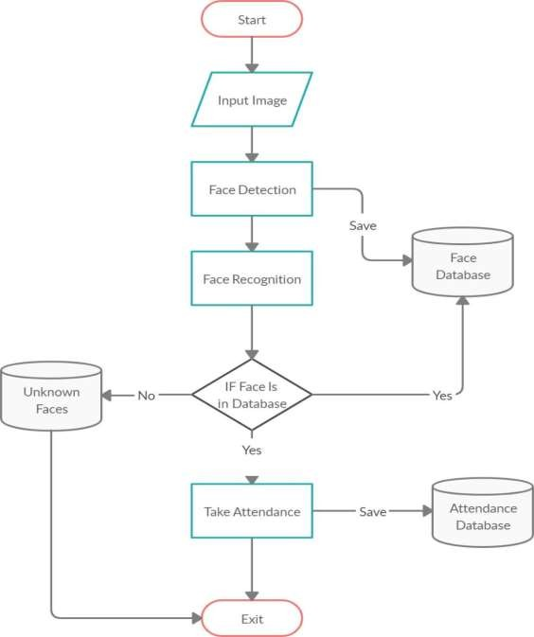

6.
- Basic Structure :

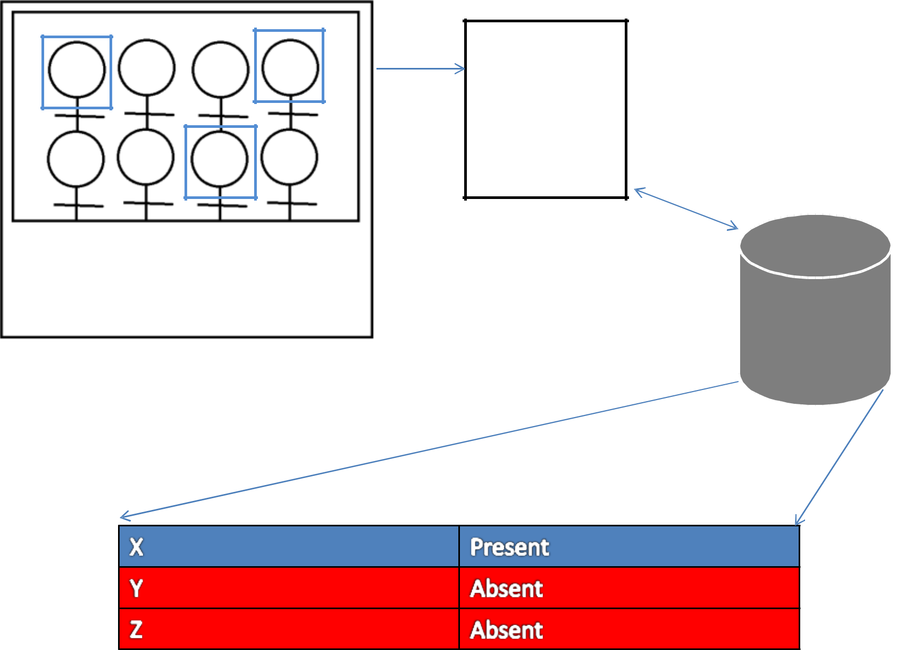

7.
- How it Works

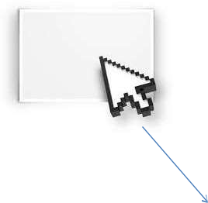

ATTENDANCE

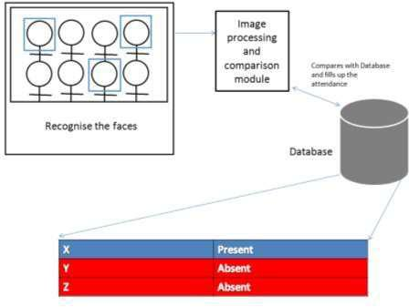

8.

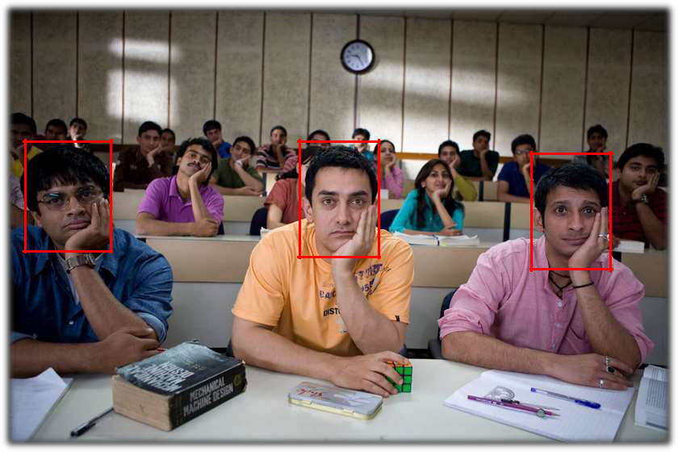

Fig.: Capturing and Analysing students face

9.
- Sequence Diagram :

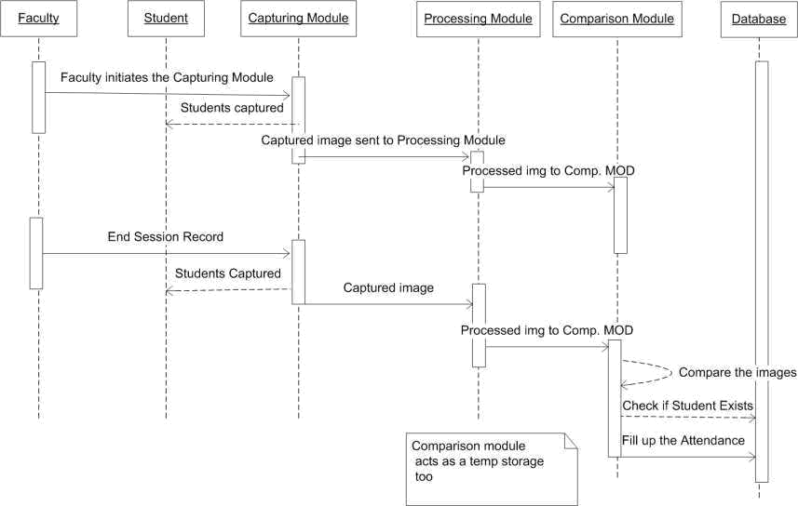

10.
- System Requirement :

Creating a smart facial attendance system involves several components and considerations. Here's a basic outline of the requirements:

- Facial Recognition Algorithm : Choose or develop a facial recognition algorithm that can accurately identify individuals from images or video feeds. Deep learning models like Convolutional Neural Networks (CNNs) are commonly used for this purpose.

- Image Database : Collect a database of facial images for each individual who will be enrolled in the system. Ensure that the database is diverse and contains images captured under different lighting conditions, angles, and facial expressions to improve recognition accuracy.

- User Enrollment Module : Develop a module for enrolling individuals into the system. This module should capture facial images of users, store them in the database, and associate them with unique identifiers (e.g., employee IDs).

- Attendance Tracking Interface : Create an interface where users can clock in and out using facial recognition. This interface can be a standalone device (e.g., a kiosk or a smartphone app) or integrated into existing attendance systems.

- Real-Time Processing : Implement real-time image processing capabilities to detect faces in live video streams and perform facial recognition against the enrolled database.

- Accuracy and Security : Ensure that the facial recognition algorithm is accurate and robust against variations in lighting, pose, facial expressions, and occlusions. Implement security measures to prevent unauthorized access or tampering with the system.

- Privacy Considerations : Address privacy concerns by implementing data protection measures and obtaining consent from individuals before enrolling their facial images into the system. Comply with relevant data protection regulations such as GDPR or CCPA.

- Scalability : Design the system to handle a large number of users and accommodate future growth. This includes efficient storage and retrieval of facial images, as well as scalable processing capabilities.

- Integration : Integrate the facial attendance system with other HR or attendance management software used by the organization. This may involve APIs or data export/import functionalities.

11.
- User Experience : Design an intuitive and user-friendly interface for both administrators and employees to interact with the system. Provide feedback during the recognition process to indicate successful clock-ins/outs.

- Maintenance and Support : Establish procedures for system maintenance, updates, and technical support to ensure smooth operation and address any issues that may arise.

- Compliance : Ensure that the system complies with relevant laws and regulations governing the collection and processing of biometric data, such as the General Data Protection Regulation (GDPR) in the European Union or the Biometric Information Privacy Act (BIPA) in the United States.

By addressing these requirements, you can develop a robust and efficient smart facial attendance system tailored to the needs of your organization.

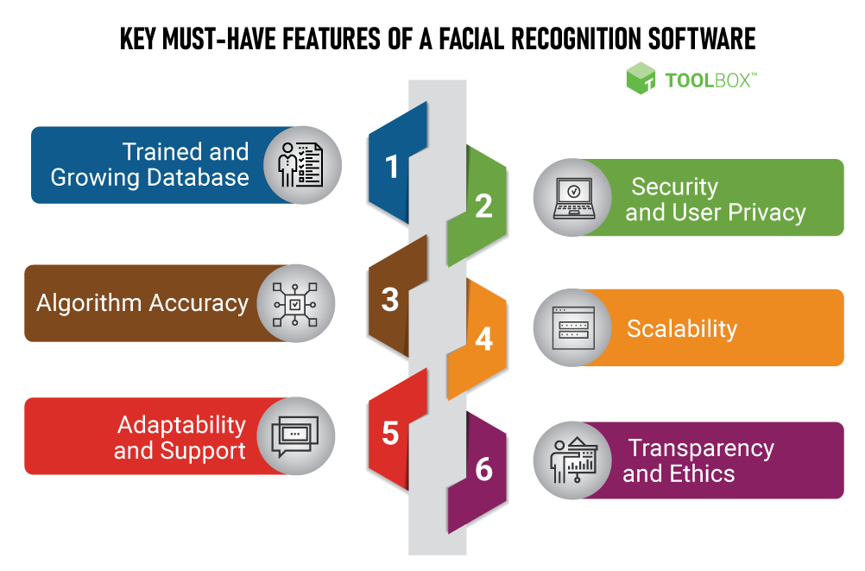

12.
- Merits:

- Smart facial attendance systems can offer high accuracy in recording attendance, reducing errors associated with manual systems or card-based systems.

- They streamline the attendance recording process, saving time for both employees and administrative staff. Employees can simply walk past the camera for their attendance to be recorded.

- Facial recognition adds an extra layer of security compared to traditional methods like ID cards or passwords, as it is difficult to impersonate someone else's face.

- Employees don't need to carry any physical tokens like ID cards or remember passwords, making the process more convenient for them.

- Administrators can monitor attendance in real-time, enabling them to take prompt actions if any issues arise.

- Demerits:

- Facial recognition technology raises privacy concerns, as it involves capturing and storing biometric data. There are concerns about how this data is stored, secured, and potentially misused.

- While facial recognition technology has improved significantly, it's not flawless. Factors such as lighting conditions, angles, and facial expressions can affect its accuracy, leading to false positives or negatives.

- There have been instances where facial recognition systems exhibited bias, especially against certain demographic groups, leading to potential discrimination issues.

- Implementing and maintaining a smart facial attendance system can be expensive, especially for smaller organizations with limited budgets.

- Facial recognition technology may not be suitable for all environments or situations. For example, it may struggle with large crowds or if individuals are wearing masks, hats, or glasses.

- Some employees may feel uncomfortable with the idea of their faces being scanned and recorded regularly, leading to resistance or morale issues in the workplace.

13.
CHAPTER – 2

LITERATURE SURVEY

Student Attendance System:

Arun Katara et al. (2017) mentioned disadvantages of RFID (Radio Frequency Identification) card system, fingerprint system and iris recognition system. RFID card system is implemented due to its simplicity. However, the user tends to help their friends to check in as long as they have their friend’s ID card. The fingerprint system is indeed effective but not efficient because it takes time for the verification process so the user has to line up and perform the verification one by one. However for face recognition, the human face is always exposed and contain less information compared to iris. Iris recognition system which contains more detail might invade the privacy of the user. Voice recognition is available, but it is less accurate compared to other methods. Hence, face recognition system is suggested to be implemented in the student attendance system.

System Type | Advantage | Disadvantages
RFID card system | Simple | Fraudulent usage
Fingerprint system | Accurate | Time-consuming
Voice recognition system |  | Less accurate compared to Others
Iris recognition system | Accurate | Privacy Invasion
Table : Advantages & Disadvantages of Different Biometric System

Digital Image Processing:

Digital Image Processing is the processing of images which are digital in nature by a digital computer. Digital image processing techniques are motivated by three major applications mainly:

- Improvement of pictorial information for human perception
- Image processing for autonomous machine application
- Efficient storage and transmission.

14.

Image Representation in a Digital Computer:

An image is a 2-Dimensional light intensity function
𝐟 (𝐱,𝐲) = 𝐫 (𝐱,𝐲) × 𝐢 (𝐱,𝐲) -(2.0)
Where, r (x, y) is the reflectivity of the surface of the corresponding image point. i (x,y) Represents the intensity of the incident light. A digital image f(x, y) is discretized both in spatial co-ordinates by grids and in brightness by quantization. Effectively, the image can be represented as a matrix whose row, column indices specify a point in the image and the element value identifies gray level value at that point. These elements are referred to as pixels or pels.

Typically following image processing applications, the image size which is used is 𝟐𝟓𝟔 × 𝟐𝟓𝟔, elements, 𝟔𝟒𝟎 × 𝟒𝟖𝟎 pels or 𝟏𝟎𝟐𝟒 × 𝟏𝟎𝟐𝟒 pixels. Quantization of these matrix pixels is done at 8 bits for black and white images and 24 bits for colored images (because of the three color planes Red, Green and Blue each at 8 bits).

Steps in Digital Image Processing:

Digital image processing involves the following basic tasks:

- Image Acquisition - An imaging sensor and the capability to digitize the signal produced by the sensor.
- Preprocessing – Enhances the image quality, filtering, contrast enhancement etc.
- Segmentation – Partitions an input image into constituent parts of objects.
- Description/feature Selection – extracts the description of image objects suitable for further computer processing.
- Recognition and Interpretation – Assigning a label to the object based on the information provided by its descriptor. Interpretation assigns meaning to a set of labelled objects.
- Knowledge Base – This helps for efficient processing as well as inter module cooperation.

15.
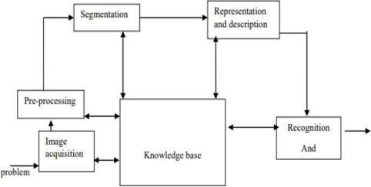
Fig : A diagram showing the steps in digital image processing

- Face Detection

Face detection is a computer vision technology that focuses on identifying and locating human faces within digital images or video frames. It is a fundamental component of various applications such as facial recognition, biometrics, image retrieval, and video surveillance. Here are some key points about face detection:

1. Localization : Face detection algorithms identify regions within an image or video frame that likely contain human faces. These algorithms typically output bounding boxes that enclose each detected face.

2. Feature Extraction : Once faces are detected, additional algorithms may be used to extract features such as facial landmarks (e.g., eyes, nose, mouth) or face descriptors (e.g., vector representations of facial features).

3. Techniques : Various techniques are used for face detection, including traditional methods like Haar cascades, Viola-Jones algorithm, and more advanced approaches like deep learning-based methods using convolutional neural networks (CNNs).

4. Challenges : Face detection faces several challenges, including variations in lighting conditions, pose (e.g., frontal, profile), facial expressions, occlusions (e.g., by glasses, hair), and scale (faces at different distances from the camera).

16.
5. Applications : Face detection has numerous applications across industries, including:

- Biometric authentication: Facial recognition for identity verification.
- Photography: Auto-focus, auto-exposure, and facial enhancement in cameras and smartphones.
- Video surveillance: Monitoring and analyzing video footage for security purposes.
- Marketing and retail: Analyzing customer demographics and behavior.
- Entertainment: Adding filters and effects in augmented reality (AR) applications.

6. Ethical and Privacy Concerns : The widespread adoption of face detection technology has raised concerns about privacy, surveillance, and potential misuse. There are debates about the appropriate use of facial recognition in public spaces and the need for regulations to safeguard individuals' privacy rights.
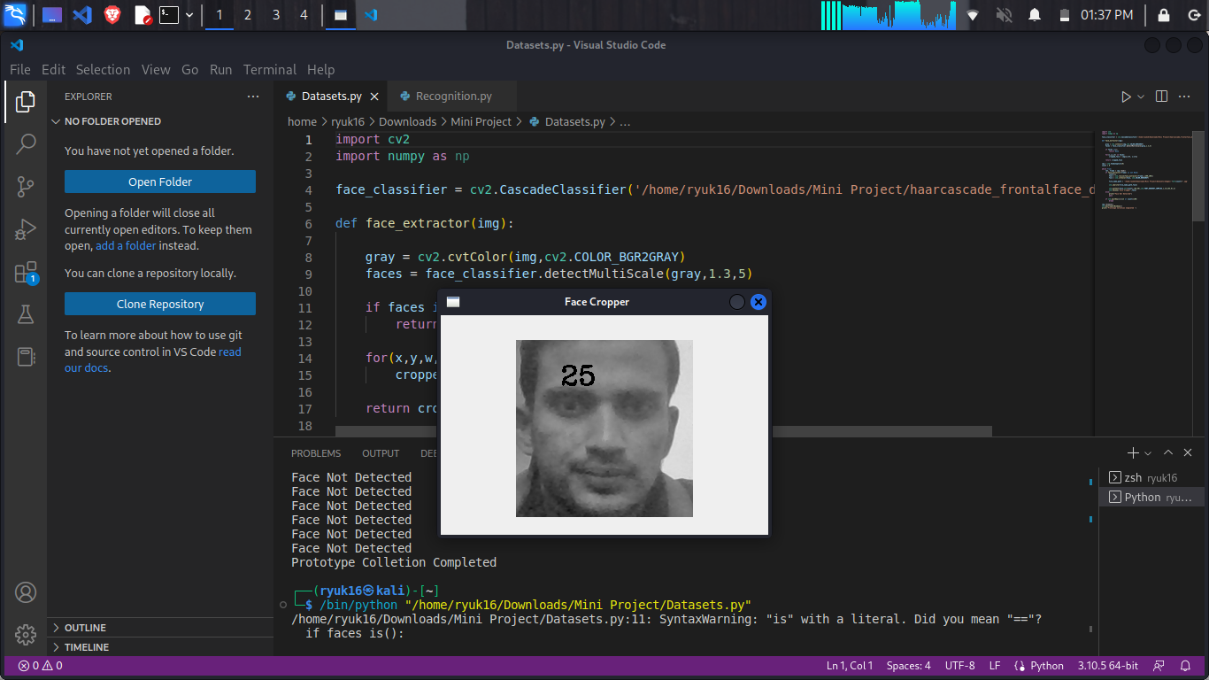
Fig.: Detecting Face and Collecting Samples

17.

Face Recognition

Face recognition is a technology that goes beyond face detection by identifying and verifying or recognizing an individual's identity based on their facial features. Here are key points about face recognition:

1. Identification vs. Verification : Face recognition can be used for two primary purposes:

- Identification: Comparing a detected face against a database of known faces to determine the identity of the person.
- Verification: Confirming whether a detected face matches a specific individual's face, typically by comparing it against a reference image or template.

2. Techniques : Face recognition algorithms employ various techniques, including traditional methods like eigenfaces, Fisherfaces, and LBPH (Local Binary Patterns Histograms), as well as more advanced deep learning-based approaches such as convolutional neural networks (CNNs).

3. Feature Extraction : Face recognition algorithms extract and analyze facial features such as the distance between eyes, nose shape, mouth shape, and other distinctive characteristics. These features are then used to create a unique representation of each individual's face, often referred to as a face template or face embedding.

4. Matching : Once facial features are extracted, the algorithm compares them against known faces or reference templates using similarity measures such as Euclidean distance or cosine similarity. If the similarity exceeds a certain threshold, the detected face is classified as a match.

5. Challenges : Face recognition systems face challenges similar to face detection, including variations in lighting conditions, pose, facial expressions, occlusions, and scale. Additionally, there are challenges related to intra-class variations (differences within the same individual's face) and inter-class similarities (similarities between different individuals' faces).

6. Applications : Face recognition has a wide range of applications across various industries, including:

- Security and law enforcement: Access control, surveillance, and criminal identification.
- Biometric authentication: Unlocking devices, verifying identities for online transactions, and securing sensitive information.
- Retail and marketing: Personalized customer experiences, targeted advertising, and demographic analysis.
- Healthcare: Patient identification, medical record management, and monitoring patient compliance.

18.
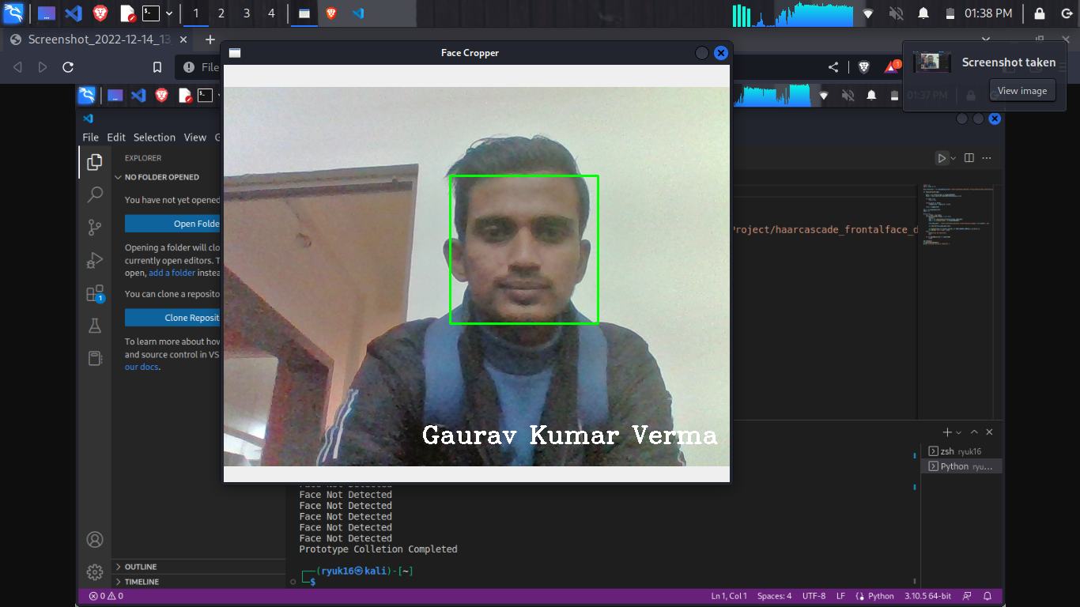
- Fig.: System Recognition the Face

Difference between Face Detection and Face Recognition

Face detection answers the question, Where is the face? It identifies an object as a “face” and locates it in the input image. Face Recognition on the other hand answers the question who is this? Or whose face is it? It decides if the detected face is someone .It can therefore be seen that face detections output (the detected face) is the input to the face recognizer and the face Recognition’s output is the final decision i.e. face known or face unknown.A face Detector has to tell whether an image of arbitrary size contains a human face and if so, where it is. Face detection can be performed based on several cues: skin color (for faces in color images and videos, motion (for faces in videos), facial/head shape, facial appearance or a combination of these parameters. Most face detection algorithms are appearance based without using other cues. An input image is scanned at all possible locations and scales by a sub window. Face detection is posed as classifying the pattern in the sub window either as a face or a non-face. The face/nonface classifier is learned from face and non-face training examples using statistical learning methods. Most modern algorithms are based on the Viola Jones object detection framework, which is based on Haar Cascades.

19.

Face Detection  Method | Advantages | Disadvantages
Viola Jones Algorithm | - High detection Speed.  - High Accuracy. | 1. Long Training Time. 2.Limited Head Pose. 3.Not able to detect dark faces.
Local Binary Pattern Histogram | - Simple computation.  - High tolerance against the monotonic illumination changes. | - Only used for binary and grey images. 2.Overall performance is inaccurate compared to Viola-Jones Algorithm.

Ada Boost Algorithm | Need not to have any prior knowledge about face structure. | The result highly depends on the training data and affected by weak classifiers.
SMQT Features and SNOW Classifier Method | - Capable to deal with lighting problem in object detection.  - Efficient in computation. | The region contain very similar to grey value regions will be misidentified as face.
Neural-Network | High accuracy only if large size of image were trained. | - Detection process is slow and computation is complex.  - Overall performance is weaker than Viola-Jones  algorithm.

Table: Advantages & Disadvantages of Face Detection Methods

Viola-Jones algorithm which was introduced by P. Viola, M. J. Jones (2001) is the most popular algorithm to localize the face segment from static images or video frame. Basically the concept of Viola-Jones algorithm consists of four parts. The first part is known as Haar feature, second part is where integral image is created, followed by implementation of Adaboost on the third part and lastly cascading process.

20.

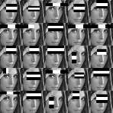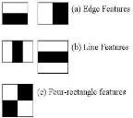

Fig.: Haar Feature

Viola-Jones algorithm analyses a given image using Haar features consisting of multiple rectangles (Mekha Joseph et al., 2016).
In the fig shows several types of Haar features. The features perform as window function mapping onto the image. A single value result, which representing each feature can be computed by subtracting the sum of the white rectangle(s) from the sum of the black rectangle(s).

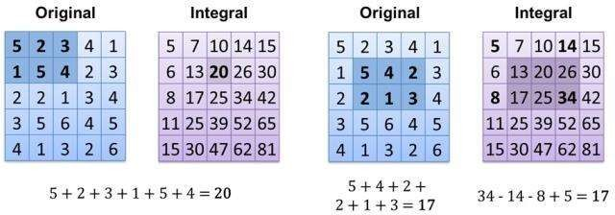

Fig.: Integral of Image

21.
The value of integrating image in a specific location is the sum of pixels on the left and the top of the respective location. In order to illustrate clearly, the value of the integral image at location 1 is the sum of the pixels in rectangle A. The values of integral image at the rest of the locations are cumulative. For instance, the value at location 2 is summation of A and B, (A + B), at location 3 is summation of A and C, (A + C), and at location 4 is summation of all the regions, (A + B + C + D). Therefore, the sum within the D region can be computed with only addition and subtraction of diagonal at location 4 + 1 − (2 + 3) to eliminate rectangles A, B and C.

Local Binary Pattern Histogram

Local Binary Pattern (LBP) is a simple yet very efficient texture operator which labels the pixels of an image by thresholding the neighborhood of each pixel and considers the result as a binary number.
It was first described in 1994 (LBP) and has since been found to be a powerful feature for texture classification. It has further been determined that when LBP is combined with histograms of oriented gradients (HOG) descriptor, it improves the detection performance considerably on some datasets. Using the LBP combined with histograms we can represent the face images with a simple data vector.

LBPH Algorithm Work Step by Step:

LBPH algorithm work in 5 steps.

1. Parameters: the LBPH uses 4 parameters:

- Radius: the radius is used to build the circular local binary pattern and represents the radius around the central pixel. It is usually set to 1.

- Neighbors: the number of sample points to build the circular local binary pattern. Keep in mind: the more sample points you include, the higher the computational cost. It is usually set to 8.

- Grid X: the number of cells in the horizontal direction. The more cells, the finer the grid, the higher the dimensionality of the resulting feature vector. It is usually set to 8.

- Grid Y: the number of cells in the vertical direction. The more cells, the finer the grid, the higher the dimensionality of the resulting feature vector. It is usually set to 8.

22.
2. Training the Algorithm: First, we need to train the algorithm. To do so, we need to use a dataset with the facial images of the people we want to recognize. We need to also set an ID (it may be a number or the name of the person) for each image, so the algorithm will use this information to recognize an input image and give you an output. Images of the same person must have the same ID. With the training set already constructed, let’s see the LBPH computational steps.

3. Applying the LBP operation: The first computational step of the LBPH is to create an intermediate image that describes the original image in a better way, by highlighting the facial characteristics. To do so, the algorithm uses a concept of a sliding window, based on the parameters radius and neighbors.

- The image below shows this procedure:

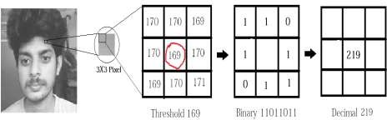
Fig.: LBP Operation

- Based on the image above, let’s break it into several small steps so we can understand it easily:

- Suppose we have a facial image in grayscale.
- We can get part of this image as a window of 3x3 pixels.
- It can also be represented as a 3x3 matrix containing the intensity of each pixel (0~255).
- Then, we need to take the central value of the matrix to be used as the threshold.
- This value will be used to define the new values from the 8 neighbors.
- For each neighbor of the central value (threshold), we set a new binary value. We set 1 for values equal or higher than the threshold and 0 for values lower than the threshold.
- Now, the matrix will contain only binary values (ignoring the central value). We need to concatenate each binary value from each position from the matrix line by line into a new binary value (e.g. 10001101). Note: some authors use other approaches to concatenate the binary values (e.g. clockwise direction), but the final result will be the same.

23.
- Then, we convert this binary value to a decimal value and set it to the central value of the matrix, which is actually a pixel from the original image.
- At the end of this procedure (LBP procedure), we have a new image which represents better the characteristics of the original image.

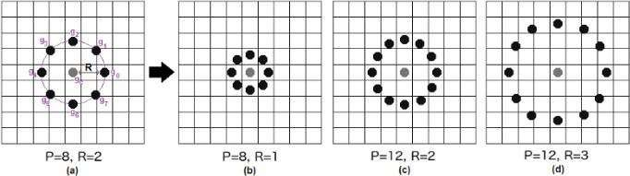

Fig.: The LBP operation Radius Change

It can be done by using bilinear interpolation. If some data point is between the pixels, it uses the values from the 4 nearest pixels (2x2) to estimate the value of the new data point.

1. Extracting the Histograms: Now, using the image generated in the last step, we can use the Grid X and Grid Y parameters to divide the image into multiple grids, as can be seen in the following image:
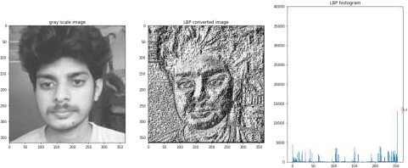
Fig.: Extracting The Histogram
24.
- Based on the image above, we can extract the histogram of each region as follows:

- As we have an image in grayscale, each histogram (from each grid) will contain only 256 positions (0~255) representing the occurrences of each pixel intensity.
- Then, we need to concatenate each histogram to create a new and bigger histogram. Supposing we have 8x8 grids, we will have 8x8x256=16.384 positions in the final histogram. The final histogram represents the characteristics of the image original image.

2. Performing the face recognition: In this step, the algorithm is already trained. Each histogram created is used to represent each image from the training dataset. So, given an input image, we perform the steps again for this new image and creates a histogram which represents the image.

- So to find the image that matches the input image we just need to compare two histograms and return the image with the closest histogram.
- We can use various approaches to compare the histograms (calculate the distance between two histograms), for example: Euclidean distance, chi-square, absolute value, etc. In this example, we can use the Euclidean distance (which is quite known) based on the following formula:
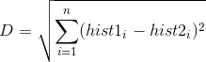
- So the algorithm output is the ID from the image with the closest histogram. The algorithm should also return the calculated distance, which can be used as a ‘confidence’ measurement.
- We can then use a threshold and the ‘confidence’ to automatically estimate if the algorithm has correctly recognized the image. We can assume that the algorithm has successfully recognized if the confidence is lower than the threshold defined.

25.
- Source Code

- Datasets :

importcv2
importnumpyasnp

face_classifier = cv2.CascadeClassifier('/home/ryuk16/Downloads/Mini Project/haarcascade_frontalface_default.xml')

defface_extractor(img):
gray = cv2.cvtColor(img,cv2.COLOR_BGR2GRAY) faces = face_classifier.detectMultiScale(gray,1.3,5) iffacesis():

returnNone
for(x,y,w,h) infaces:
cropped_face = img[y:y+h, x:x+w]
returncropped_face
cap = cv2.VideoCapture(0)
count = 0
whileTrue:
ret, frame = cap.read()
ifface_extractor(frame) isnotNone:
count+=1
face = cv2.resize(face_extractor(frame),(200,200))
face = cv2.cvtColor(face, cv2.COLOR_BGR2GRAY)
file_name_path = '/home/ryuk16/Downloads/Mini Project/Datasets/Images/'+str(count) +'.jpg'
cv2.imwrite(file_name_path,face)
cv2.putText(face,str(count),(50,50),cv2.FONT_HERSHEY_COMPLEX,1,(0,255,0),2)

cv2.imshow('Face Cropper',face)
else:
print("Face Not Detected")
pass
ifcv2.waitKey(1)==13orcount==100:
break
cap.release()
cv2.destroyAllWindows()

print('Prototype Colletion Completed ')

26.
- Output :

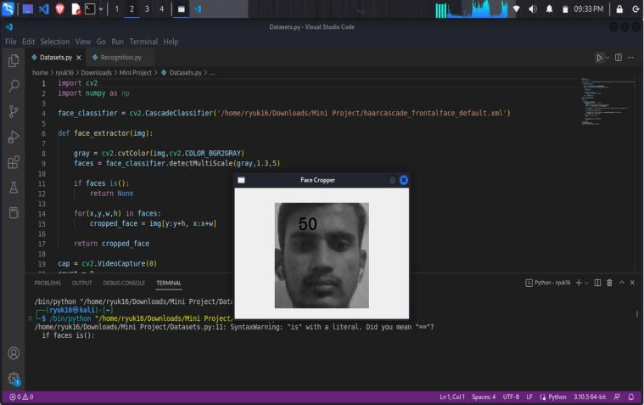

- Recognition :

import cv2

import numpy as np

from os import listdir

from os.path import isfile, joi

data_path = '/home/ryuk16/Downloads/Mini Project/Datasets/Images/' onlyfiles = [f for f in listdir(data_path) if isfile(join(data_path,f))] Training_Data, Labels = [], []
for i, files inenumerate(onlyfiles):

image_path = data_path + onlyfiles[i]
images = cv2.imread(image_path, cv2.IMREAD_GRAYSCALE)
Training_Data.append(np.asarray(images, dtype=np.uint8))
Labels.append(i)

27.
Labels = np.asarray(Labels, dtype=np.int32)
model = cv2.face.LBPHFaceRecognizer_create()
model.train(np.asarray(Training_Data), np.asarray(Labels))
print("Dataset Model Is Trained")
face_classifier = cv2.CascadeClassifier('/home/ryuk16/Downloads/Mini Project/haarcascade_frontalface_default.xml')
defface_detector(img, size = 0.5):
gray = cv2.cvtColor(img, cv2.COLOR_BGR2GRAY)
faces = face_classifier.detectMultiScale(gray,1.3,5)
if faces is():
return img,[]
for(x,y,w,h) in faces:
cv2.rectangle(img, (x,y),(x+w,y+h),(0,255,0),2)
roi = img[y:y+h, x:x+w]
roi = cv2.resize(roi, (200,200))
return img,roi
cap = cv2.VideoCapture(0)
whileTrue:
ret, frame = cap.read()
image, face = face_detector(frame)
try:
face = cv2.cvtColor(face, cv2.COLOR_BGR2GRAY)
result = model.predict(face)
if result[1] < 500:
confidence = int(100*(1-(result[1])/300))
if confidence > 86:
cv2.putText(image, "Gaurav Kumar Verma", (250, 450), cv2.FONT_HERSHEY_COMPLEX, 1, (255, 255, 255), 2) cv2.imshow('Face Cropper', image)
else:
cv2.putText(image, "Unknown", (250, 450), cv2.FONT_HERSHEY_COMPLEX, 1, (0, 0, 255), 2)
cv2.imshow('Face Cropper', image)
except:
cv2.putText(image, "Face Not Detected", (250, 450), cv2.FONT_HERSHEY_COMPLEX, 1, (255, 0, 0), 2)
cv2.imshow('Face Cropper', image)
pass

28.
if cv2.waitKey(1)==13:

break
cap.release()

cv2.destroyAllWindows()

- Output :
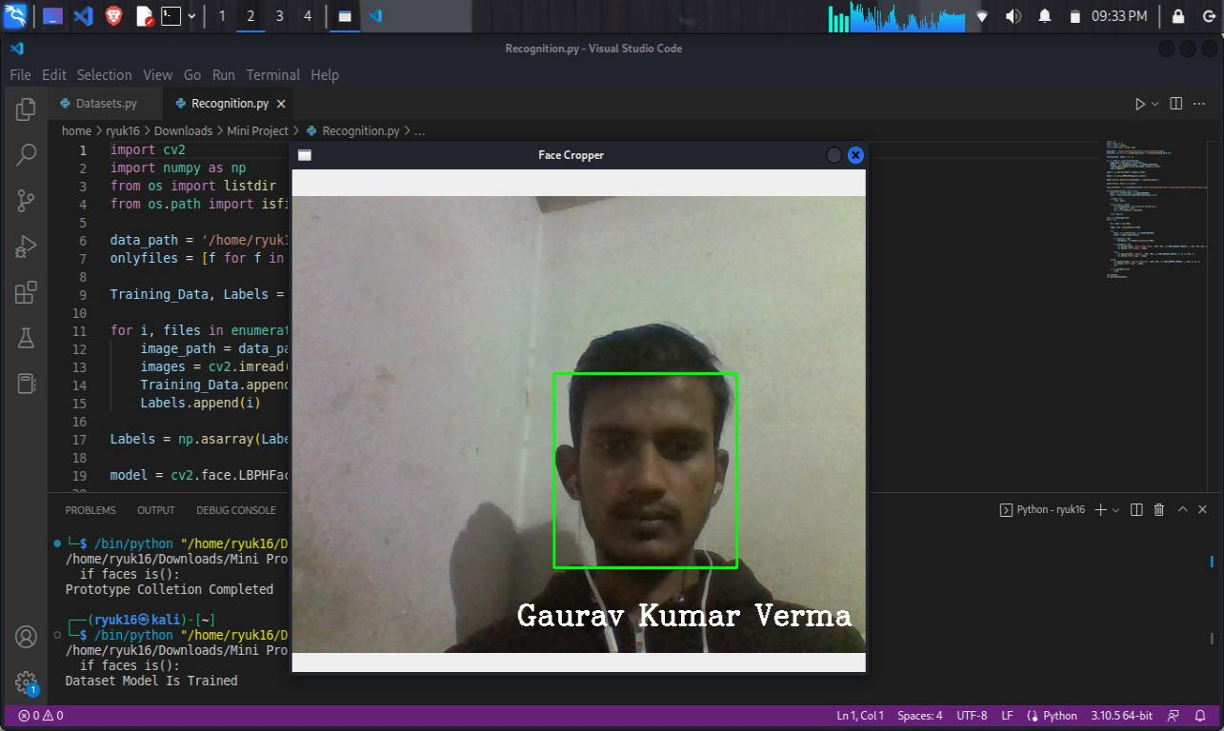

29.
CHAPTER – 3

OBJECTIVE AND SCOPE OF THE PROJECT

- It’s Objective

The primary objective of a Smart Facial Attendance System is to automate and enhance the process of recording attendance by utilizing facial recognition technology. This system aims to improve efficiency, accuracy, security, and convenience in attendance tracking while providing real-time monitoring, data insights, compliance assurance, cost-effectiveness, integration with existing systems, and an enhanced user experience.

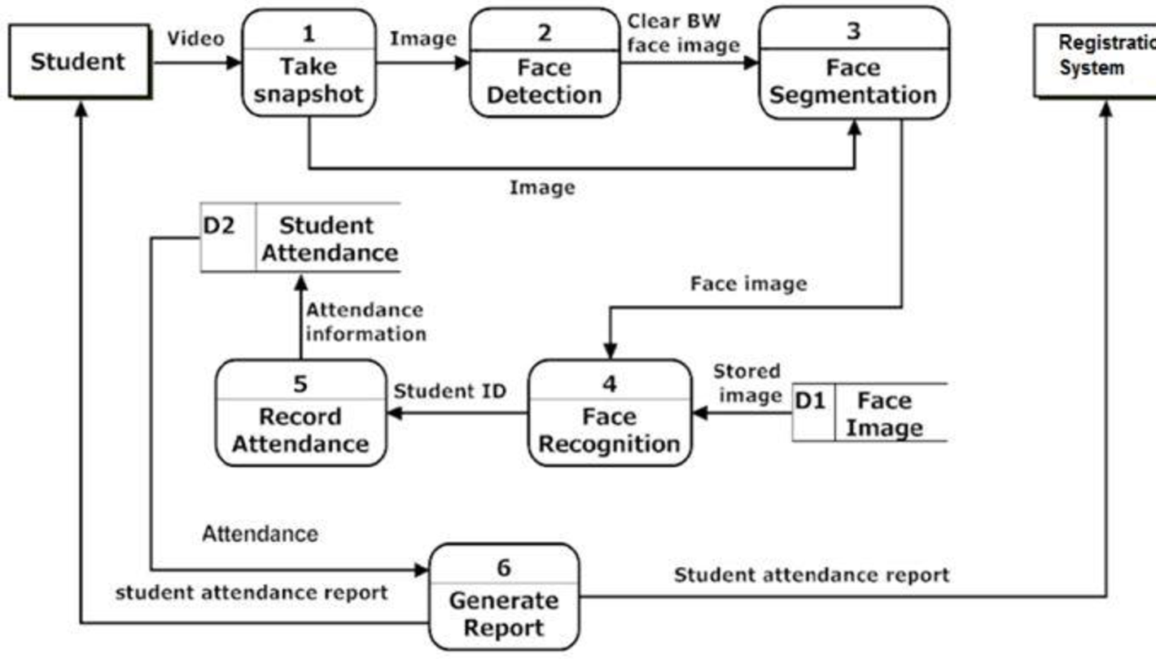
Fig.: Steps for Automated Facial Recognition Attendance System

30.
The objective of a Smart Facial Attendance System is to automate and improve the process of recording attendance in various contexts, typically in workplaces, educational institutions, or any other environment where attendance tracking is necessary. The primary goals and objectives of implementing such a system include:

1. Efficiency : Streamlining the attendance recording process to save time for both employees/students and administrative staff. With facial recognition technology, attendance can be recorded quickly and accurately without the need for manual input or physical tokens.

2. Accuracy : Ensuring accurate attendance records by eliminating errors associated with manual systems (e.g., paper-based sign-in sheets) or traditional methods (e.g., swipe cards, biometric scanners).

3. Security : Enhancing security measures by using biometric authentication through facial recognition, which is difficult to forge or manipulate compared to traditional methods like ID cards or passwords.

4. Convenience : Providing convenience for employees, students, or attendees by eliminating the need to carry physical tokens (e.g., ID cards) or remember passwords. They can simply walk past the facial recognition camera for their attendance to be recorded.

5. Real-time Monitoring : Enabling administrators to monitor attendance in real-time, allowing for prompt intervention or follow-up if attendance issues arise.

6. Data Insights : Generating data insights and analytics on attendance patterns, trends, and anomalies, which can be useful for resource planning, scheduling, and performance evaluation.

7. Compliance : Ensuring compliance with attendance-related regulations, policies, or contractual obligations by maintaining accurate and verifiable attendance records.

8. Cost-effectiveness : Optimizing resource utilization and minimizing costs associated with manual attendance tracking processes, such as labor costs for administrative staff or the expense of producing and managing physical tokens.

9. Integration : Facilitating integration with existing systems and workflows, such as human resource management systems (HRMS), student information systems (SIS), or access control systems, to streamline operations and data management.

10. User Experience : Improving the overall user experience for employees, students, or attendees by providing a seamless and frictionless attendance recording process.

31.
The objective of a Smart Facial Attendance System is to leverage facial recognition technology to automate and enhance the attendance tracking process, with a focus on efficiency, accuracy, security, convenience, compliance, cost-effectiveness, integration, data insights, and user experience. An attendance system that uses face recognition eliminates such time fraud as well unfairness against honest workers. Not only will you take attendance, but you will also record the employees' entry and exit times. Time and attendance can be managed on mobile devices with the face recognition app.

The main objective of a Smart Facial Attendance System is to automate and optimize the process of recording attendance using facial recognition technology. This system aims to improve efficiency, accuracy, and security in attendance tracking while simplifying the user experience and providing real-time monitoring capabilities.

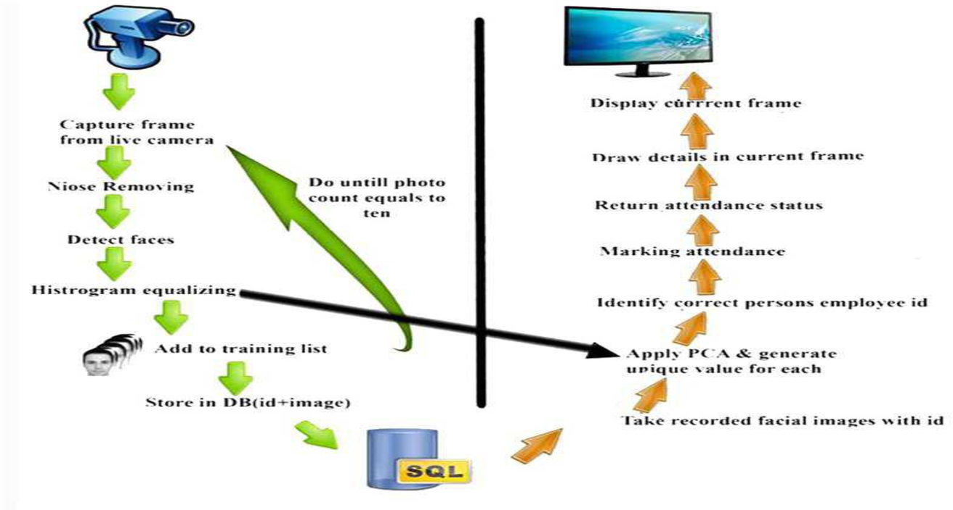
Figure 1: Detailed system design of face recognition

32.

- It’s Scope

We are setting up to design a system comprising of two modules. The first module (face detector) is a mobile component, which is basically a camera application that captures student faces and stores them in a file using computer vision face detection algorithms and face extraction techniques. The second module is a desktop application that does face recognition of the captured images (faces) in the file, marks the students register and then stores the results in a database for future analysis.

The scope of a Smart Facial Attendance System involves the development and implementation of two main modules: a mobile face detection component and a desktop face recognition application. This system captures student faces using computer vision techniques, recognizes them, marks attendance, and stores the results in a database for future analysis. Key aspects include face detection algorithms, face recognition technologies, database management, user interfaces, integration, security, scalability, and performance optimization.

The scope of a Smart Facial Attendance System encompasses various aspects related to its design, implementation, functionality, and potential applications. Here's an overview of the scope:

1. Hardware and Software Components : This includes the development or selection of appropriate hardware components such as cameras, facial recognition sensors, and computing devices, as well as the software infrastructure needed to process facial data, manage attendance records, and provide user interfaces for administrators and users.

2. Facial Recognition Algorithms : The system must incorporate robust facial recognition algorithms capable of accurately detecting and identifying faces in different lighting conditions, angles, and facial expressions. This may involve implementing machine learning models, deep learning architectures, or other advanced techniques for facial feature extraction and matching.

3. Integration with Existing Systems : The Smart Facial Attendance System may need to integrate with existing infrastructure such as HRMS (Human Resource Management Systems), access control systems, or student information systems. This ensures seamless data exchange and compatibility with organizational workflows.

4. Security and Privacy Considerations : The system must address security and privacy concerns associated with biometric data collection and storage. This involves implementing encryption protocols, access controls, and compliance with relevant data protection regulations to safeguard sensitive facial data.

33.
5. User Interfaces : User-friendly interfaces should be designed for administrators to manage the system settings, view attendance reports, and perform administrative tasks. Additionally, intuitive interfaces for end-users (employees, students) are essential to facilitate the attendance recording process.

6. Scalability and Performance : The system should be scalable to accommodate varying numbers of users and locations. It should also be optimized for performance to handle real-time facial recognition tasks efficiently, especially in high-traffic environments.

7. Training and Support : Training sessions and support documentation should be provided to system administrators and end-users to ensure effective use of the Smart Facial Attendance System. Ongoing technical support and maintenance are also crucial for resolving issues and keeping the system operational.

8. Customization and Flexibility : The system should offer customization options to adapt to specific organizational requirements and preferences. This may include configuring attendance policies, defining access levels, or integrating additional features such as temperature screening or mask detection.

9. Data Analytics and Reporting : The system may include features for analyzing attendance data, generating reports, and extracting actionable insights. This can help organizations make informed decisions related to resource allocation, scheduling, and performance evaluation.

10. Compliance and Regulatory Requirements : Compliance with relevant laws, regulations, and industry standards governing biometric data usage (e.g., GDPR, CCPA) is essential. The system should adhere to legal requirements and ethical guidelines to ensure responsible use of facial recognition technology.

The scope of a Smart Facial Attendance System encompasses a comprehensive range of technical, functional, and operational aspects aimed at optimizing attendance tracking processes while addressing security, privacy, and usability considerations.
Face recognition technology offers a higher level of accuracy compared to conventional methods. By identifying individuals based on unique facial features, the system significantly reduces the risk of errors and ensures reliable attendance tracking.

34.

